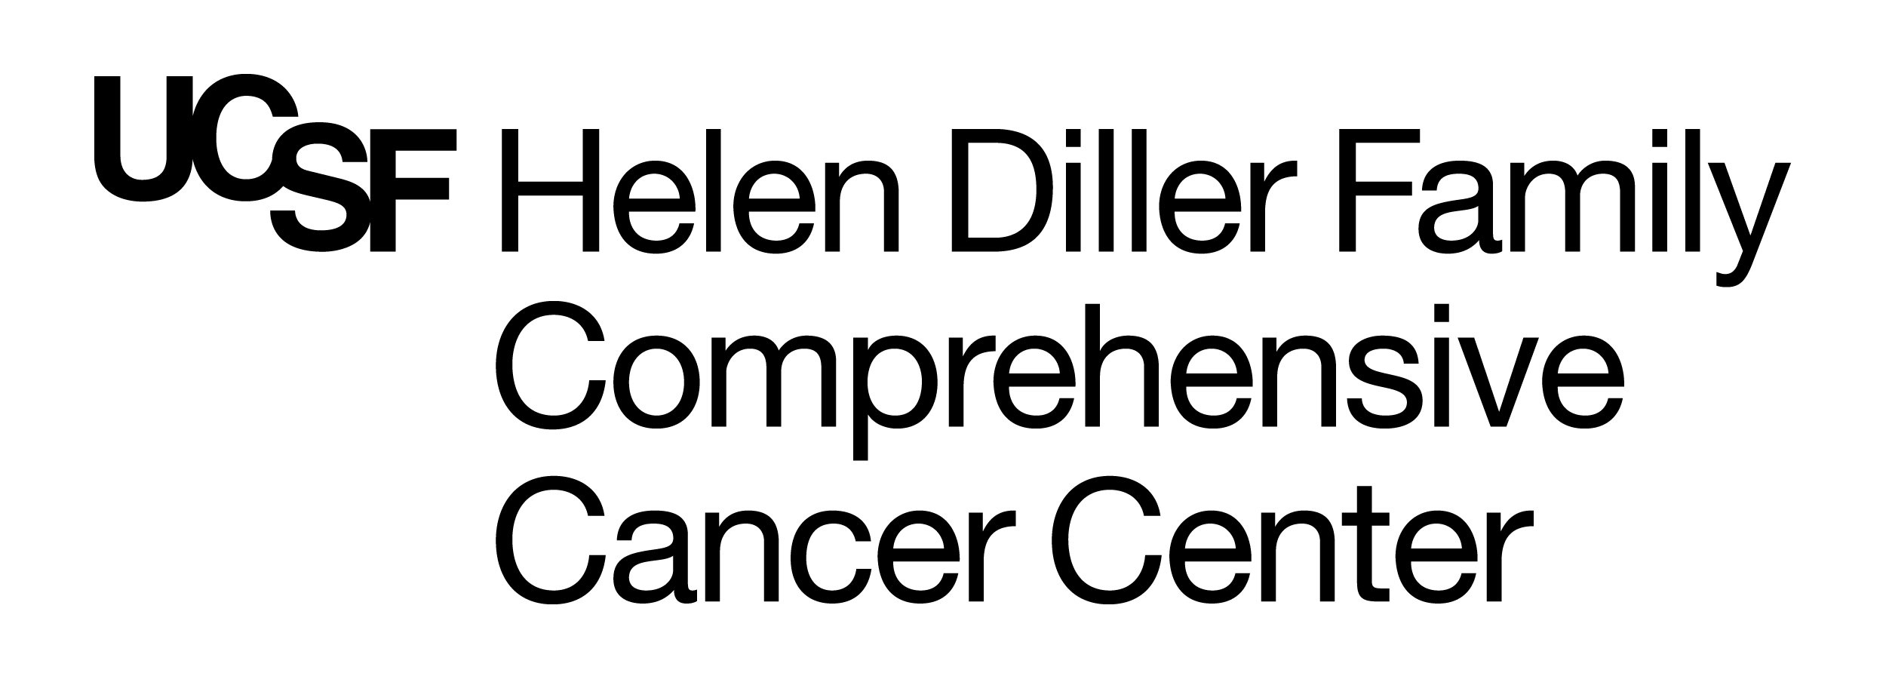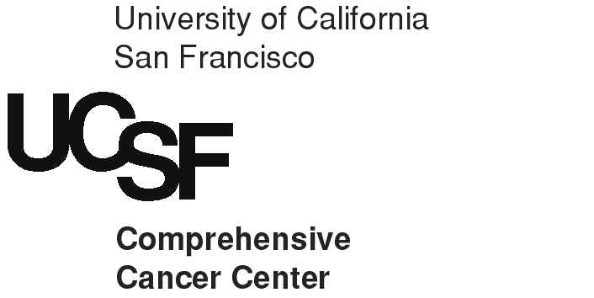

Breast Science Advocacy Core
Breast Oncology Program
2340 Sutter Street
UCSF Box 0808
San Francisco, CA 94143-0808

Tel.: 415-476-3461

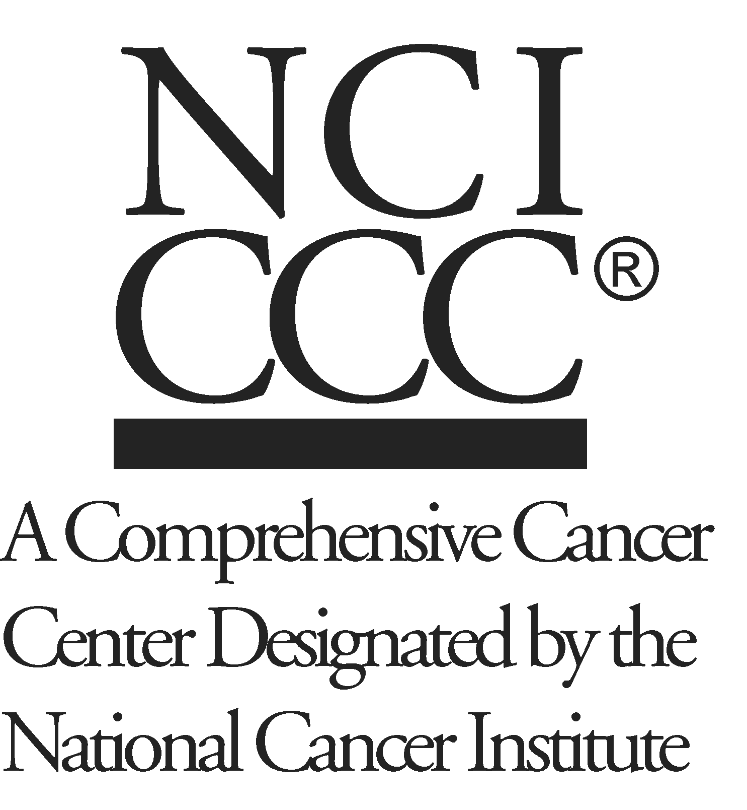
UCSF Breast Cancer Research Advocate Opportunity

Who we are looking for:
Breast cancer survivors, women identified as being at high risk, and their care givers and family members with an interest in breast cancer research who would like to become an advocate for patient-focused research with the UCSF Breast Science Advocacy Core (BSAC). (No medical science background is required. Advocates must be at least one year beyond their initial diagnosis date.)

UCSF Breast Oncology Program and how Advocates help advance its goals:
The Breast Oncology Program (BOP) supports and stimulates basic, clinical, and population research in breast cancer and facilitates the translation of these findings into improved cancer management and control. Breast Science Advocacy Core Research Advocates provide the UCSF breast cancer research community with a global patient perspective. The Core is currently composed of 12 volunteer team members, who interface between Breast Oncology Program researchers and the community.

Activities of Research Advocates:
BSAC advocates:
- Are interested in clinical trials and current research trends and issues.
- Meet and work with researchers on their projects and protocols.
- Attend research seminars led by researchers from UCSF and other institutions.
- Help develop new ideas for projects or assist in leading existing projects.
- Contribute to projects and forums addressing current and emerging challenges facing the cancer research community.
- Organize and participate in training workshops led by Advocates
- Provide community education on the importance of participating in clinical trials and tissue research and on advances in breast cancer research.

Note: time commitment depends on activity involvement.

What we would like to know about you:
If this sounds like an interesting volunteer opportunity to you, please provide the following information:
- A Letter describing: 1) your interest in or experience with science/medicine and/or breast cancer research; 2) your experience working in groups; 3) your community activities; 4) your special interests and strengths that may enhance the mission and goals of the UCSF Breast Science Advocacy Core.
- Resumé or other summary that includes professional, volunteer and leadership history.
- Contact information: Name, address, phone number and email address

Please send your application to: Breast Oncology Program Admin, UCSF Box 0808,
2340 Sutter St., San Francisco, CA 94143. Or email to: Vantveer.admin@ucsf.edu

For more information: http://cancer.ucsf.edu/research/programs/breast/breast-science-advocacy-core

